Exercise 1: Histology of Epithelial Tissues

Data Table 1: Microscopic Examination of Epithelial Tissues
Slide | Epithelial Tissue (Ciliated, Exchange, Protective, Transporting, or Secretory) | Photograph | Types of Cells Seen on Slide (Simple or Stratified; Squamous, Cuboidal or Columnar; Ciliated, Villi)
Simple columnar epithelial tissue of Stomach (CS of stomach wall)
Thyroid gland and Parathyroid on same slide
Simple squamous epithelial tissue from lung
Stratified squamous (epidermis) and non-keratinized stratified squamous (from esophagus)
Pseudostratified, ciliated columnar and pseudostratified cuboidal epithelium (trachea, bronchi, nasal cavity)

Exercise 2: Histology of Connective Tissue

Data Table 2: Histology of Connective Tissue
Type of Connective Tissue | Photograph | Characteristics
Loose
Dense
Adipose and Supportive | 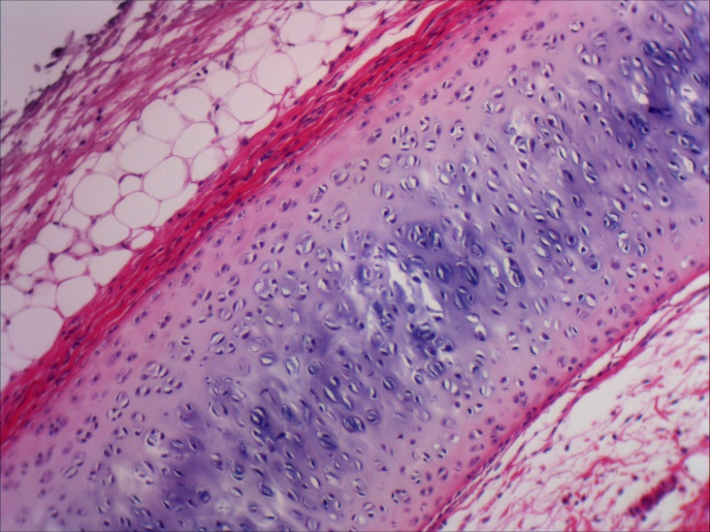
Other:  _______ | 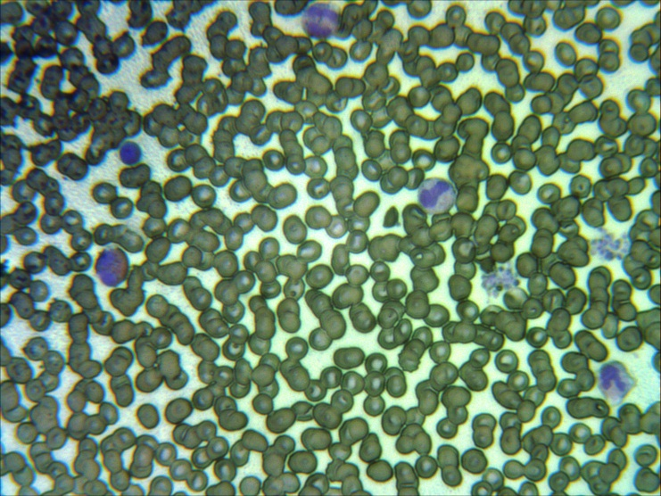

Exercise 3: Muscle and Nerve Histology

Data Table 3: Muscle and Nerve Histology
Type of Tissue | Photograph | Characteristics
 | 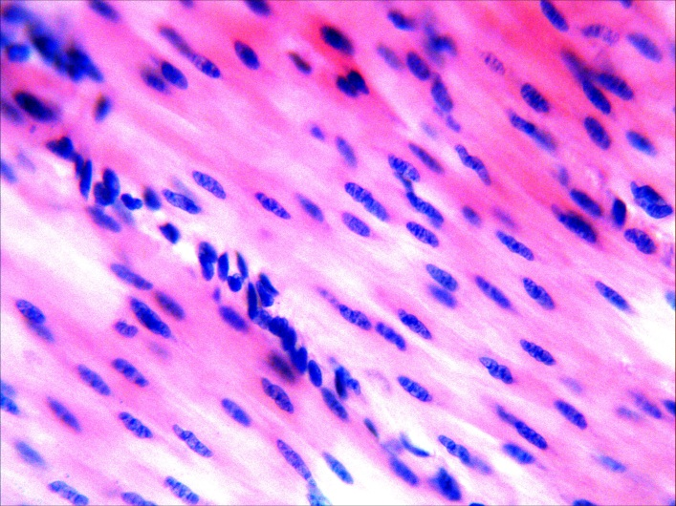
 | 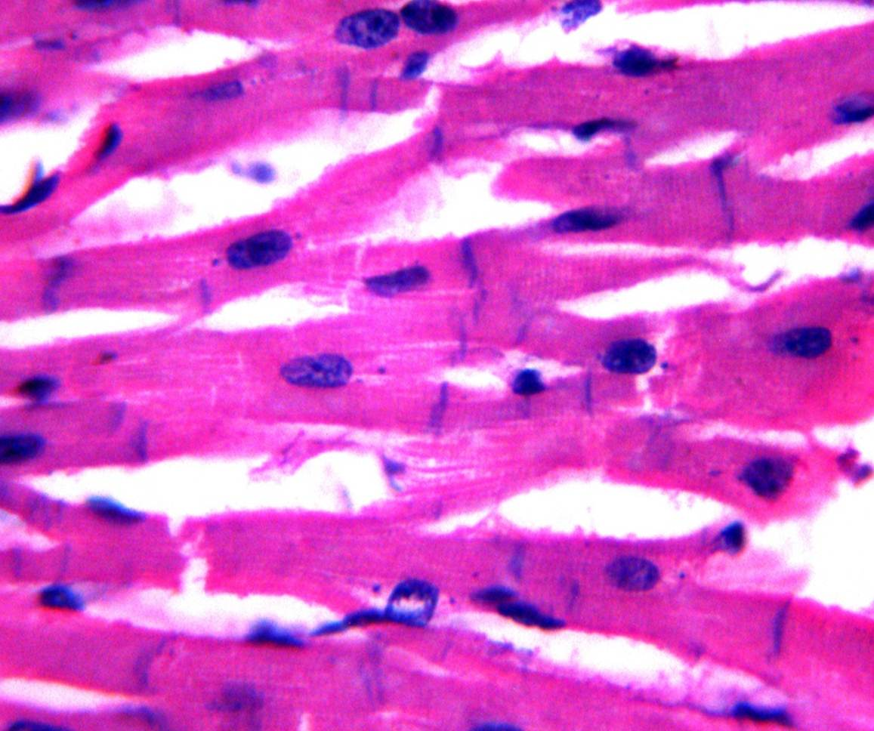
 | 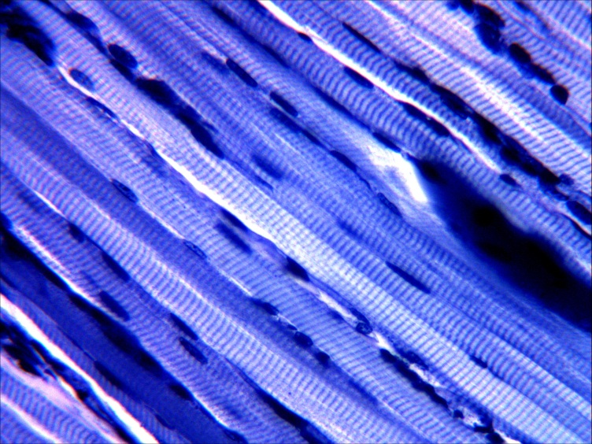
Nervous Tissue | 

